**EXPERIMENT 1: INSTALLING JAVA DEVELOPMENT KIT**

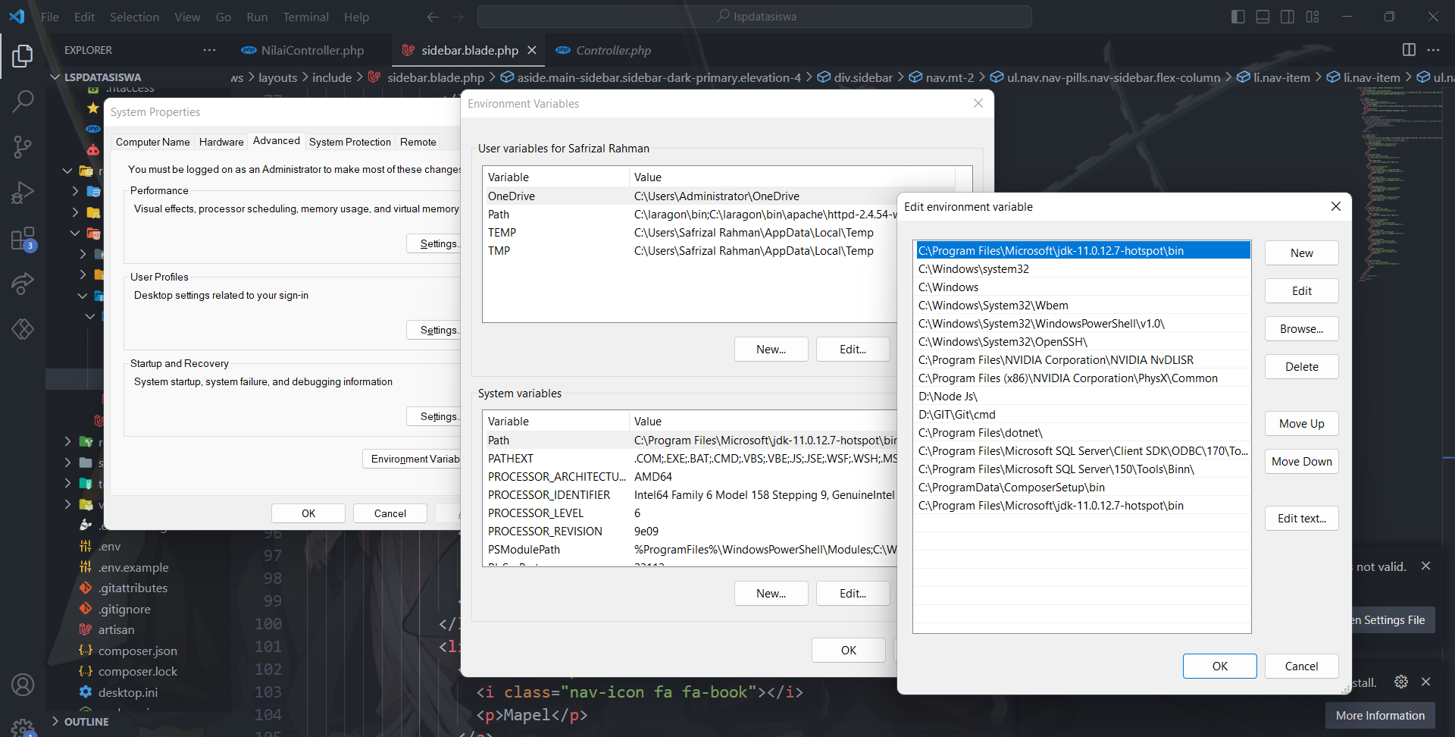

1. Is Used from entering the location of the java JDK bin folder into the PATH in Control Panel → System → Advanced System Settings → Environment Variable, is to put and located the java.bin (JDK file bin) or exe.files because PATH is environtmen variable that used by operating system for locate the files of them and PATH is stores a brunch of shortcuts.

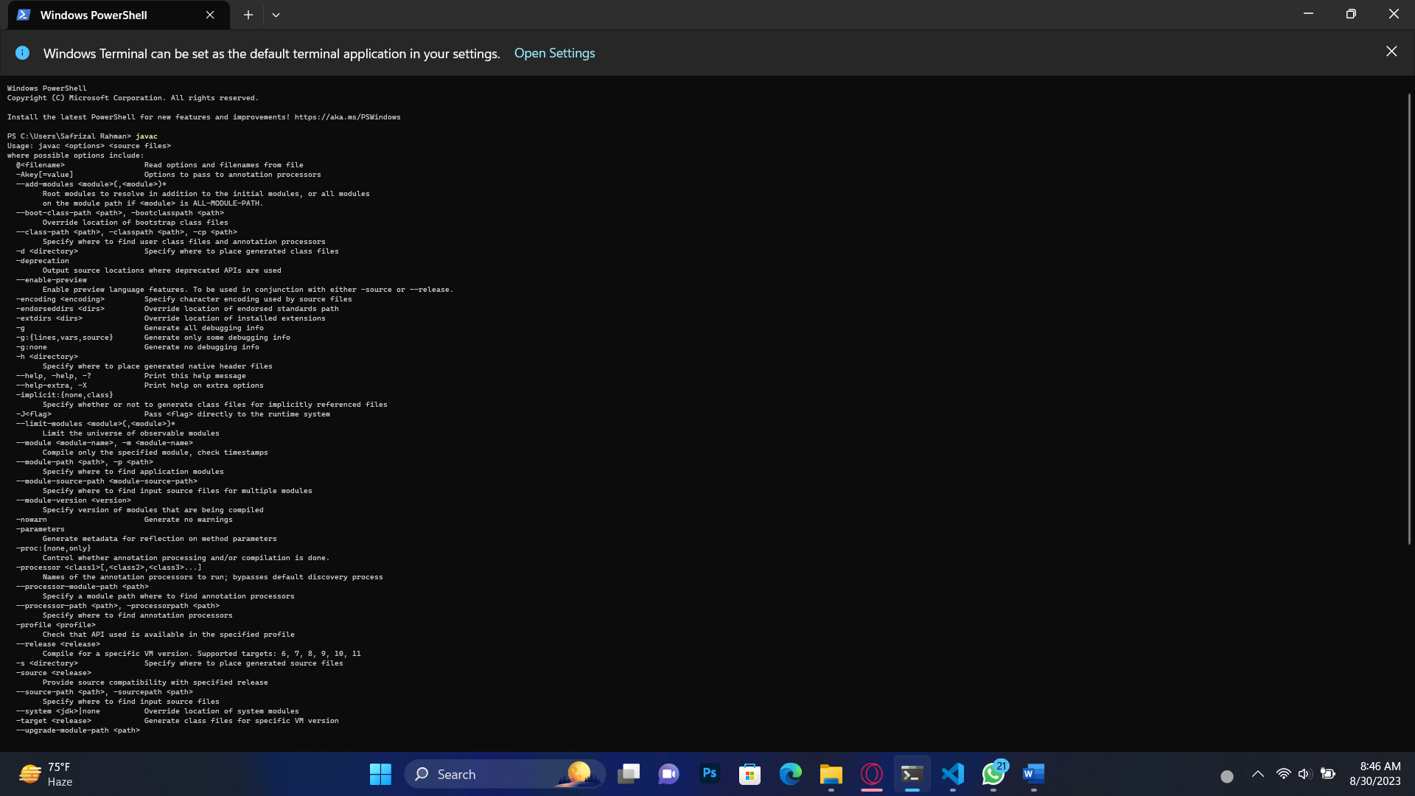

1. Used from using javac command in CMD (Command prompt) or in Terminal Windows Powershell is to check and recheck about the java JDK is ready to use or not because if we before have add JDK to PATH.

And javac have another function and used to Sntax Checking, Semantic analysis, compilation to bytecode.

**EXPERIMENT 2: Basic Structure of Java**

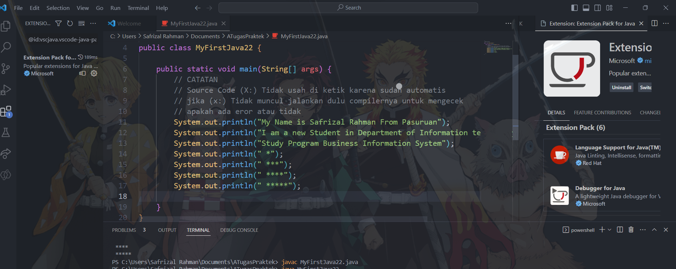

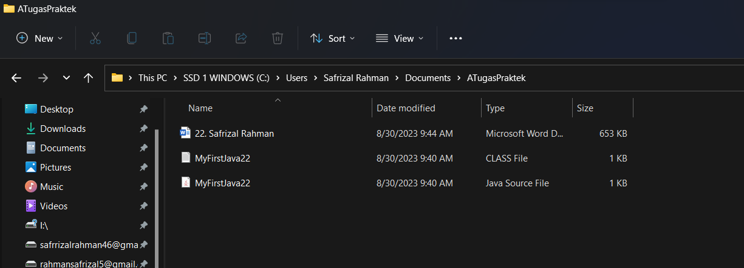

1. The Function of javac MyFirstJava22.java is to compile the File and source code with Automatically make in sam file folder one file with the type File is a CLASS file.

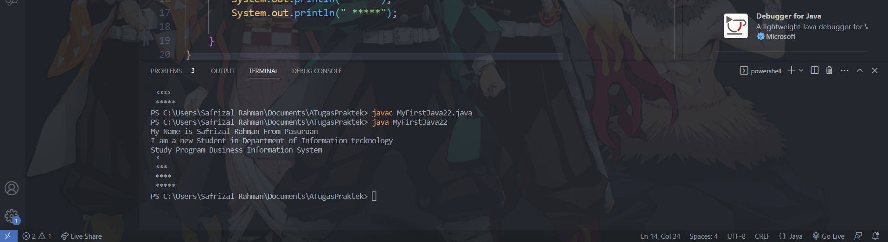

1. The Function of java MyFirstJava22 is to run the file after we compiled for run and bring up results from the source code we write, if there any eror repeatedly the step from javac and check the source code.

**EXPERIMENT 3: Adding Extensions to visual Studio Code**

1. Result from Change the command System.out.println to System.out.print on lines 7 and 8, then run the program again.

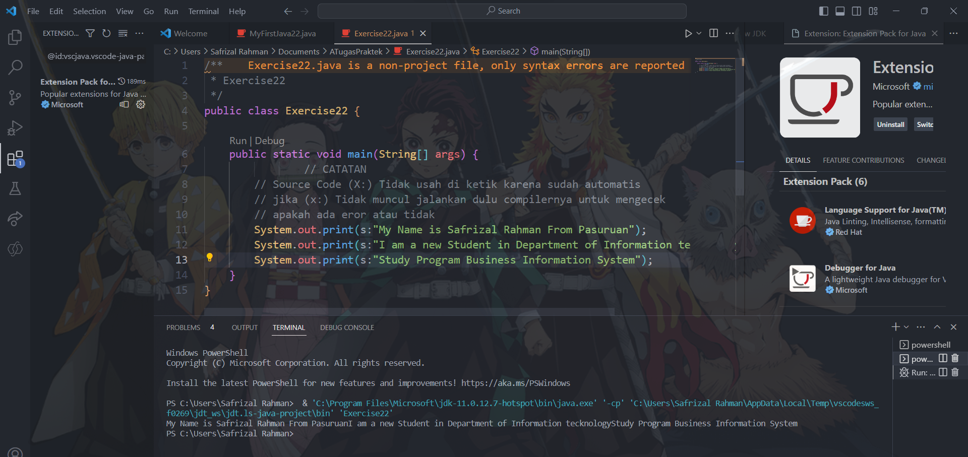

1. The Result from Change the command System.out.println to System.out.print on lines 7 and 8, then run is a the previous result of after compiling and running the difference is that the output was based now after the ln word was removed to 1 paragraph only and lined up without any spaces in each code system.out.print and system.out.println.
2. Result from Change the command on line 7 with added command \n is in the above picture.

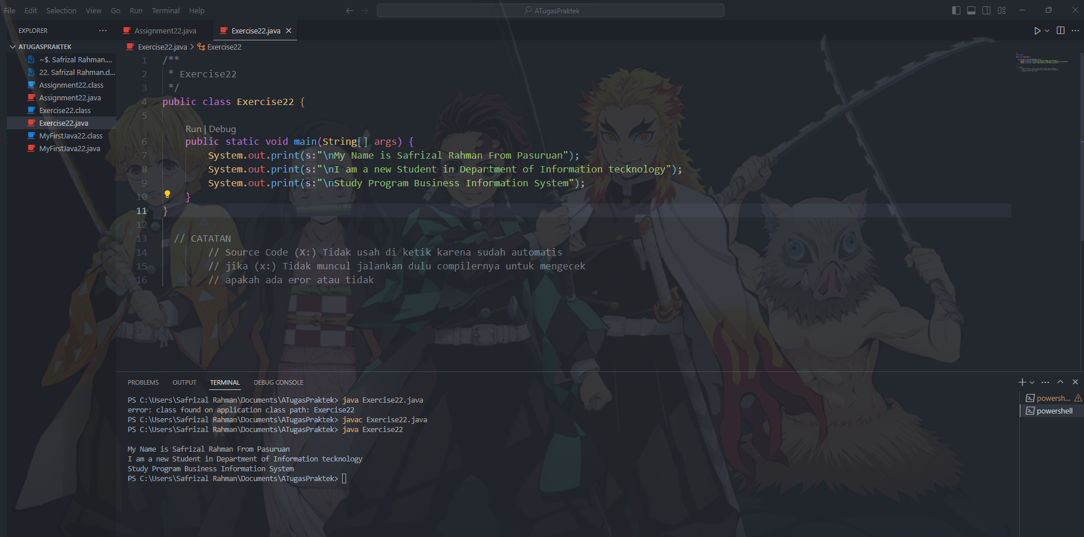

1. Function of the comman \n on line 7 from the command it will disappear output after it is run is to make the command d LN discarded so that the results become fibrous without spaces in some parts and not neat with the command \n this makes the output more neat and lined up.

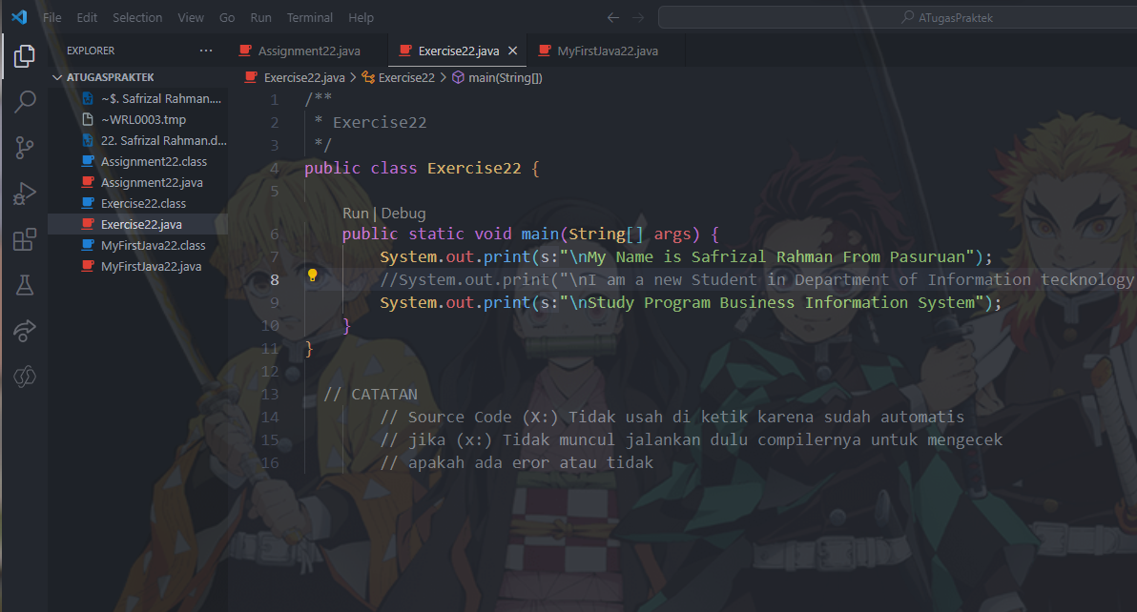

1. The function of a slash or slash command that amounts to two is to turn off one line of source code is usually used for debugging and also usually to check if there are errors in code.

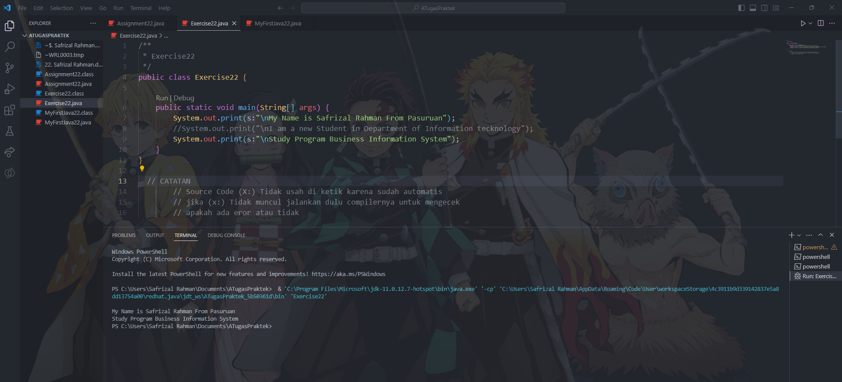

1. Result from Run the program is in output line 8 not showed the result while line 7 and 9 have output result.

ASSGNMENT 22

